Elton, Gruber, Brown, and Goetzmann
Modern Portfolio Theory and Investment Analysis, 9th Edition
Solutions to Text Problems: Chapter 21

Chapter 21: Problem 1

We can use the cash flows bonds A and B to replicate the cash flows of bond C. Let Y_{A} be the fraction of bond A purchased and Y_{B} be the fraction of bond B purchased. (Note that these are not investment weights that sum to 1.) Then we have:

t = 1: $100 Y_{A} + $80 Y_{B} = $90

t = 2: $1,100 Y_{A} + $1,080 Y_{B} = $1,090

Solving the above two equations simultaneously gives Y_{A}= Y_{B} = 1/2. So buying 1/2 of bond A and 1/2 of bond B gives the same cash flows as buying 1 bond C (or, equivalently, buying 1 bond A and 1 bond B gives the same cash flows as buying 2 of bond C). Therefore, if the Law of One Price held, the bonds’ current prices would be related as follows:

1/2 P_{A} + 1/2 P_{B} = P_{C}

But, since we are given that P_{A} = $970, P_{B} = $936 and P_{C} = $980, we have instead:

1/2 × $970 + 1/2 × $936 = $953 < $980

The Law of One Price does not hold.

Given that the future cash flows of the portfolio of bonds A and B are identical in timing and amount to those of bond C, and assuming that all three bonds are in the same risk class, an investor should purchase 1 bond A and 1 bond B rather than 2 of bond C.

Chapter 21: Problem 2

A.
A bond’s current yield is simply its annual interest payment divided by its current price, so we have:

Current Yield = $100 ÷ $960 = 0.1042 (10.42%)
B.
A bond’s yield to maturity is the discount rate that makes the sum of the present values of the bond’s future cash flows equal to the bond’s current price. Since this bond has annual cash flows, we need to find the rate, y, that solves the following equation:
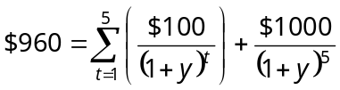

We can find y iteratively by trial and error, but the easiest way is to use a financial calculator and input the following:

PV = − 960

PMT = 100

FV = 1000

N = 5

After entering the above data, compute I to get I = y = 11.08%.

Chapter 21: Problem 3

In general, the nominally annualized spot rate for period t (S_{0t}) is the yield to maturity for a t-period zero-coupon (pure discount) instrument:

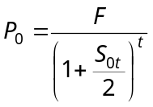

where P₀ is the zero’s current market price, F is the zero’s face (par) value, and t is the number of semi-annual periods left until the zero matures.

The zero-coupon bonds in this problem all have face values equal to $1,000.

If semi-annual periods are assumed, then bond A is a one-period zero, bond B is a two-period (one-year) zero, bond C is a three-period zero, and bond D is a four-period (two-year) zero.

So we have:

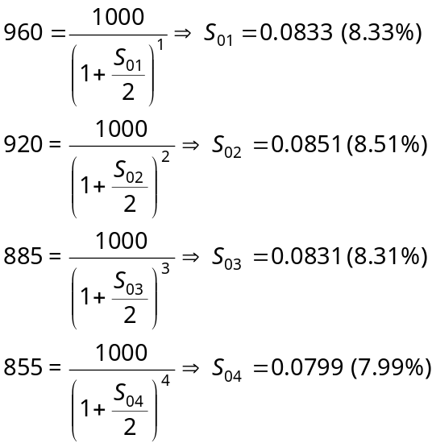

The nominally annualized implied forward rates (f_{t,t+j}) can be obtained from the above spot rates. A general expression for the relationship between current spot rates and implied forward rates is:

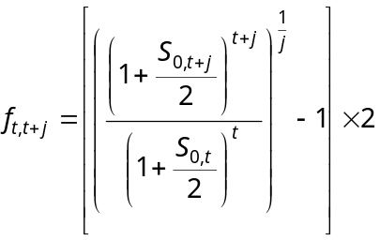

where t is the semi-annual period at the end of which the forward rate begins, j is the number of semi-annual periods spanned by the forward rate, and both t and j are integers greater than 0.

We can an obtain a set of one-period forward rates by setting j equal to 1 and varying t from 1 to 3 in the preceding equation:

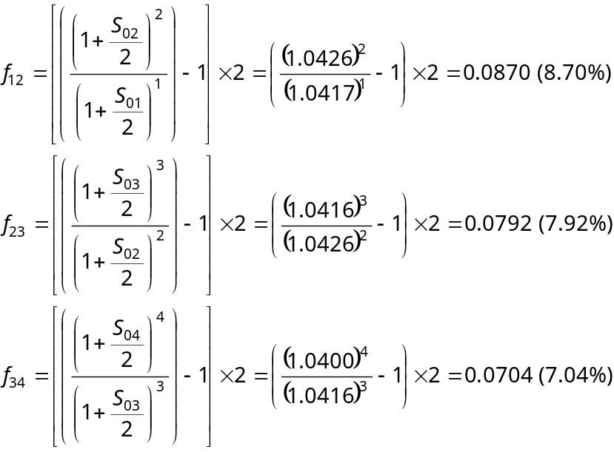

If instead we wanted the expected spot yield curve one period from now under the pure expectations theory, we can set t equal to 1 and vary j from 1 to 3 in the preceding equation:

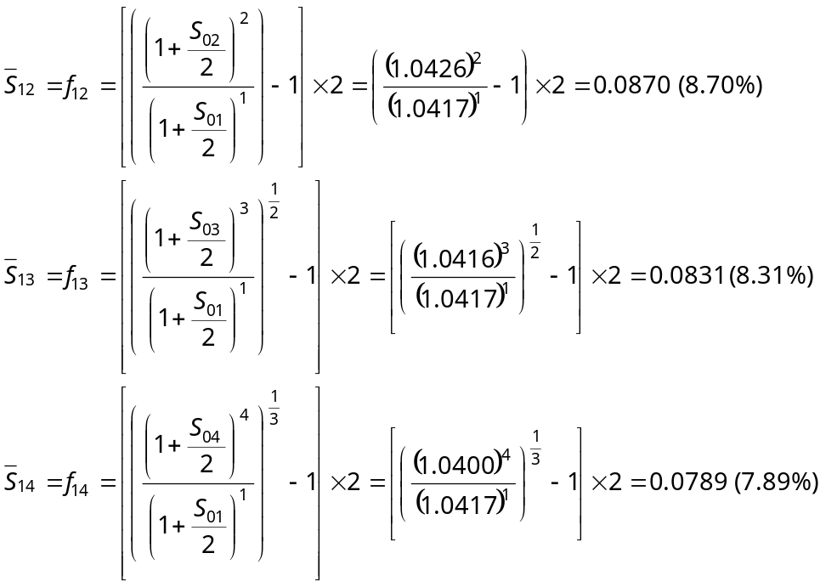
Chapter 21: Problem 4

We can use the cash flows bonds A and B to replicate the cash flows of bond C. Let Y_{A} be the fraction of bond A purchased and Y_{B} be the fraction of bond B purchased. Then we have:

t = 1: $80 Y_{A} + $1,100 Y_{B} = $120

t = 2: $1,080 Y_{A} + $0 Y_{B} = $1,120

Solving the above two equations simultaneously gives:

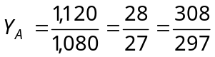

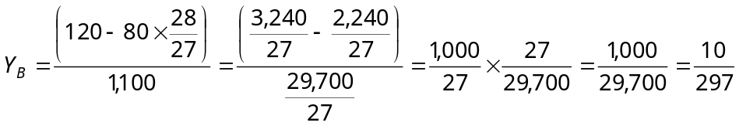

So buying 308/297 of bond A and 10/297 of bond B gives the same cash flows as buying 1 bond C (or, equivalently, buying 308 of bond A and 10 of bond B gives the same cash flows as buying 297 of bond C). Therefore, if the Law of One Price held, the bonds’ current prices would be related as follows:

308/297 P_{A} + 10/297 P_{B} = P_{C}

But, since we are given that P_{A} = $982, P_{B} = $880 and P_{C} = $1,010, we have instead:

308/297 × $982 + 10/297 × $880 = $1,048 > $1,010

The Law of One Price does not hold. For the Law of One Price to hold, bond C would have to sell for $1,048.

Chapter 21: Problem 5

If the Law of One Price holds, then the same discount rate (which is a spot rate) applies for the cash flows in a particular period for all three bonds. Also, in the presence of taxes, the price of each bond must equal the sum of the present values of its future after-tax cash flows, where the present values are calculated using the spot rates.

Each bond’s capital gain or loss is simply its principal (par) value minus its price. Given that each bond has a par value of $1,000, bond A has a capital gain of $1,000 − $985 = $15, bond B has a capital gain of $1,000 − $900 = $100, and bond C has a capital loss of $1,000 − $1,040 = − $40.

Given that the periods shown are annual, that taxes must be paid on capital gains and can be deducted on capital losses, and that the capital gain or loss tax rate is one-half of the ordinary income tax rate, we need to find the discount factors and ordinary income tax rate that makes the following set of equations hold simultaneously:

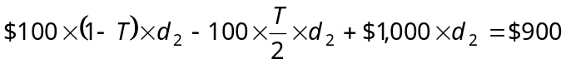

where

T = the ordinary income tax rate;

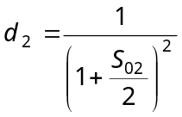 = the two-semi-annual-period (one-year) discount factor;

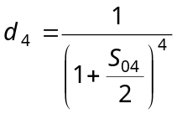 = the four-semi-annual-period (two-year) discount factor.

The solution to the above set of simultaneous equations is:

T = 0.3303; d₂ = 0.8568; d₄ = 0.8934

